*Cover page template for Diploma Thesis*

**Bulgarian Diploma Thesis**

**Vehicle Fleet Management System**

**Anton Kovachev, ID#200172680**

**Student: Anton Kovachev**  **, Date: 11/29/2024**

*signature*

**Supervisor: Vladimir Georgiev**  **, Date:**

*signature*

**Department of Computer Science, AUBG**

**Blagoevgrad, 2024**

**Declaration template for Senior Project and Diploma Thesis**

**Title**: Vehicle Fleet Management System

**Author**: Anton Kovachev

**Abstract:** The goal of the Management System will be to offer a broad range of tools to both Clients and Deliverers for transportation. The system will be a platform to manage and monitor both cargo and vehicles, and how they are combined into orders. Some of the key functionalities of the system are cargo detailing, choosing deliveries, vehicle monitoring and assignment. The aim of these features would be to enable transportation companies to optimize resources and as a whole improve efficiency and profitability, while at the same time making operations for clients easier. The system will focus on an easy-to-use interface, since it has to be operated by people with varying degrees of technological experience, from admins to drivers and clients, as well as giving them the tools they need to carry out their business.

**Declaration of authorship:**

“The Senior Project/Bulgarian Diploma Thesis presented here is the work of the author solely, without any external help, under the supervision of Vladimir Georgiev. All sources, used in development, are cited in the text and in the Reference section.”

Author: Anton Kovachev

**Table of Contents**

**1. Introduction** 1

Description of the Application 1

Why did I choose this project? 2

Overview of the used technologies 3

HTML 3

CSS 3

PHP 4

JavaScript 4

XAMPP 5

phpMyAdmin 5

Visual Studio Code 6

Bootstrap 6

**2. Specification and Analysis of Software Requirements** 7

Functional Requirements 7

Non-functional Requirements 9

**3. Design of the Software Solution** 10

UML Component Diagrams 12

Diagram of the project’s database 13

*Figure 2* Login and Registration Validation Schema 13

Description of Application’s Software Architecture and Algorithms 16

Index and About Pages 17

Client Login and Registration 17

Client’s My Orders Page 18

Client’s My Profile Page 23

Deliverer Login and Registration 24

Deliverer’s Offers Page 25

Deliverer’s My Profile Page 30

Admin Login and Registration 32

Admin Orders Page 33

Admin Vehicles Page 34

Admin Reviews Page 35

Admin Accounts Page 36

Security Features and Reliability Considerations 36

**4. Implementation** 38

Installation Requirements 38

**5. Testing** 40

Figure 3 Home Page 40

Figure 4 About page 41

Figure 5 Registration Errors 42

Figure 6 Logged In Client View 43

Figure 7 Adding an Order 44

Figure 8 Added Order 45

Figure 9 Add a Vehicle 45

Figure 10 Added Vehicle 46

Figure 11 Approving the Order and Vehicle 46

Figure 12 Approving the Order and Vehicle 46

Figure 13 Haggling and Sending the Contract Back 47

Figure 14 Contract Accepted by Both 48

Figure 15 Contract Accepted by Both Confirmation 48

Figure 16 Delivery Update by Deliverer 49

Figure 17 Delivery Details Client View 49

Figure 18 Client Confirming the Completion of a Delivery and Leaving a Review 50

Figure 19 Approving the Review 51

Figure 20 Review on the Deliverer’s Page 51

**6. Results and Conclusions** 52

Results vs. Initial Hopes 52

Encountered Issues 53

Future Development 53

Lessons Learned 54

**7. References** 55

# **1. Introduction**

## Description of the Application

For the given task of creating a Senior Project, I decided to create a website. Through this website, people would be able to get goods/freight from one point to another. Through a user-friendly interface, people with varying experience of using websites would be able to use it, from simple people needing to get their furniture moved, all the way to delivery companies with fleets of vehicles, offering their services on the platform.

The website will offer its services to both clients and deliverers alike, providing a connection between the two, so that people who require a delivery, and those who can perform the delivery, can get in touch.

The website presents a different view for each of the users, depending on whether they are a client or a deliverer. Through the client view, the client can post an “offer”, announcing that they have a shipment that needs transportation. They can enter details about the shipment, such as dimensions, weight and description, after which it has to be approved by the admins. Upon submission for approval, the client can then monitor the status of their “order”. If the offer is approved, the client will be able to begin looking for deliverers, whose capabilities match what the client requires, or wait until a deliverer themself picks them up on their offer and contacts them. After a successful completion of an order, clients can then leave a review for the performed service. All of these features become available only after a person makes a registration as a client.

The deliverer view gives the option for deliverers to monitor the vehicles registered on their name, and their status. Deliverers’ vehicles first have to be approved by the admins, who would validate whether the vehicle is suitable and has the capabilities to carry out their duties. Deliverers can always make changes to the information about their fleet, but every change has to be approved by an admin. Deliverers also have access to a page that shows them the offers that clients have put up, allowing them to choose if they want to make the first move and contact the client, if they have their ability matches the requirements of the offer.

The admins are the centerpiece of the website, being the ones who approve both the vehicles and the offers, as well as the contracts and reviews that follow, while also responsible for approving any changes. Admins have the ability to monitor the profiles of both deliverers and clients, able to terminate accounts if necessary.

## Why did I choose this project?

During my recent trip to the Bulgarian seaside, I couldn't help but notice the numerous billboards and signs advertising people in need of transport for their goods, or offering vehicles for those seeking to move items.

It gave me an idea – a platform that would seamlessly connect both sides, making it easy for individuals to find exactly what they’re looking for. Recognizing that users with varying levels of familiarity with technology could be searching for transport, I realized how important it was to design the website with simplicity and accessibility in mind. The goal was to create a user-friendly experience that would effortlessly guide anyone, regardless of their technical expertise, to the information they need in a clear and straightforward manner.

## Overview of the used technologies

For the purposes of the project I have used HTML, CSS, PHP, JavaScript, XAMPP and phpMyAdmin. The Integrated Development Environment that was used for the project is Visual Studio Code, due to its many features and ease of use.

### HTML

HTML or Hypertext markup language is the fundamental technology beneath all webpages. HTML Code is basically the structure of a webpage that defines how its content is organized and displayed, allowing browsers to understand and render text, images, and other multimedia elements in a unified manner. HTML is made up of various tags and elements that are the building blocks of the various sections and parts of a webpage like the header, images, paragraphs, list, etc. Such a structural base enables developers to build logical layouts to serve both content display and interactive features. Its the skeleton of any webpage, commonly accompanied with CSS for designing and JavaScript for interactivity. (<https://developer.mozilla.org/en-US/docs/Learn/Getting_started_with_the_web/HTML_basics>)

### CSS

CSS, or Cascading Style Sheets, is the language that adds styling to the elements we created with HTML, altering their properties, such as their colors, fonts, borders, etc., giving color and form to the webpage, making it more appealing. While a webpage without CSS can indeed still technically work, CSS can often be beneficial, as it allows the content to be more adaptable and pleasant to interact with visually compared to the plain text of HTML. (<https://www.geeksforgeeks.org/css-introduction/>)

### PHP

PHP, also known as PHP: Hypertext Preprocessor,” is an open-source, server-side scripting language, widely used for web development. The versatility that PHP offers allows it to handle server-side tasks, such as handling forms, processing data, and managing sessions alongside HTML content, when PHP is embedded within HTML.

PHP is highly efficient in server-side scripting, but it’s also capable of command-line scripting and, to a lesser extent, desktop applications. Another advantage is PHP’s efficient performance; its quick load times help optimize website speed, which is a critical factor for a better user experience. (<https://codeinstitute.net/global/blog/what-is-php-programming/>)

### JavaScript

JavaScript is a scripting language that enables user interaction and dynamic elements on webpages, which is crucial for making the webpage feel like more than just static content, which in not what I want, if I want more engagement from the user. In a certain way it is the third layer if core web development technologies, working alongside HTML for structure and CSS for styling. JavaScript allows for real-time interactions, like handling user inputs, displaying updates, and animating graphics.

JavaScript is event-driven, meaning that it can execute functions in response to specific actions, like button clicks and/or keystrokes. It also supports storing values in variables, manipulating text, and performing calculations, which makes it versatile for tasks on the client side. JavaScript is integral to creating seamless user experiences by enabling a page to respond to users’ actions without server requests, which in turn makes the website faster and more engaging. (<https://developer.mozilla.org/en-US/docs/Learn/JavaScript/First_steps/What_is_JavaScript>)

### XAMPP

XAMPP is an open-source, cross-platform webserver solution which lets developers test out their web applications on a local server. XAMPP integrates Apache HTTP server, MariaDB, and interpreters for PHP and Perl, which is where the name XAMPP comes from, with the X standing for cross-platform. All of these features make XAMPP a really good toolkit for web development and testing without the need for an internet connection, and since it is compatible with the major operating systems like Windows, macOS, and Linux, it is a really good solution for simplifying the process of deploying and managing applications locally.

XAMPP’s main components offer essential web functionality: Apache serves web content, MariaDB stores and manages data, while PHP and Perl provide scripting capabilities for creating dynamic content. XAMPP also includes a control panel that lets users start and stop services, manage configurations, and access useful add-ons like phpMyAdmin, which provides a graphical interface for managing MariaDB databases. (<https://www.javatpoint.com/xampp>)

### phpMyAdmin

phpMyAdmin is a free, open-source tool that simplifies the management of MySQL and Maria DB databases through a web interface. phpMyAdmin is written in PHP and it enables database admins to perform crucial database operations like creating, modifying, and deleting tables and databases without needing very complex command-line interactions.

phpMyAdmin’s graphical user interface makes it easy to execute SQL queries, import or export data, and manage database permissions, and users can store query results in various formats, including CSV, PDF, and XML, making reporting and data migration easier. Features like query-by-example (QBE) and advanced search functions, help users quickly find and manipulate data across databases. (<https://www.educba.com/what-is-phpmyadmin/>)

### Visual Studio Code

VS Code, often known as Visual Studio Code, is a lightweight code editor that comes in desktop and online versions. VS Code was created with Electron, Node.js, and TypeScript. It supports JavaScript and TypeScript, two essential web languages, and has a large ecosystem of extensions that support Python, C++, PHP, and other languages. With hundreds of choices, Visual Studio Code provides a wide range of extensions to meet various demands that may come up while working.

Features like IntelliSense for code autocompletion, integrated Git support, debugging tools, and code refactoring—all of which are available through an easy interface—are what set Visual Studio Code apart. The editor's adaptability to different debugging tools is further enhanced by its Language Server Protocol (DAP). (<https://www.infoworld.com/article/2335960/what-is-visual-studio-code-microsofts-extensible-code-editor.html>)

### Bootstrap

Bootstrap is a free and open-source front-end framework designed for building websites and web applications. It is specifically created to facilitate the development of mobile-first, responsive websites and offers a set of syntax for creating template designs.

As a framework, Bootstrap provides the foundational elements needed for responsive web development, allowing developers to simply place their code within a pre-structured grid system. Built on HTML, CSS, and JavaScript, Bootstrap enables web developers to create websites more efficiently, eliminating the need to spend time on basic commands and functions. (Zola)

# **2. Specification and Analysis of Software Requirements**

## Functional Requirements

* User Types and Roles: the system will support three types of users: clients (customers needing delivery), deliverers (service providers), and administrators (managing the platform). Each user type will have specific functionalities and access rights
* Client functionality
  + Clients can create and submit delivery offers, specifying shipment details such as dimensions, weight and type
  + Offers must be approved by administrators before being visible to deliverers
  + Clients can monitor the status of their offers post-submission and search for deliverers based on their requirements
  + After the delivery is completed, clients can leave review for deliverers
* Deliverer functionality
  + Deliverers must register and have their vehicles be approved by administrators before being able to apply for orders
  + Deliverers can view their registered vehicles and their statuses
  + Deliverers can browse client offers and choose to contact clients if they meet the requirements of the offers
  + Deliverers can update their vehicle information, which then has to be approved by the administrators
* Administrator functionality
  + Administrators will have full control over the platform, including the ability to approve or deny client offers, contracts, reviews, vehicles, and accounts
  + Admins can monitor user profiles and have the authority to terminate accounts if necessary
* Website features
  + A user-friendly home page that provides clear navigation for both clients and deliverers
  + A review section that displays client reviews of delivery services, approved by moderators
  + A dedicated page for viewing and managing delivery offers, distinct for clients and deliverers, along with the ability to communicate between clients and deliverers.

## Non-functional Requirements

* Usability – the interface must be intuitive and accessible for users with varying levels of experience in web applications, ensuring a seamless experience
* Design and Aesthetics – the website should have a clean, appealing design that aligns with the branding of the service, including appropriate use of colors, fonts, and images
* Performance – the application must have reduced response times to ensure smooth navigation, with the capability to handle multiple simultaneous users without performance degradation
* Security – the system must ensure data security, especially for user information, through hashing and secure access controls
* Error handling – the application should provide clear and informative error messages for incorrect inputs during registration and login processes
* Scalability – the architecture should allow for future enhancements, such as adding new features or scaling to accommodate more users and deliverers as the platform grows

# **3. Design of the Software Solution**

In order to set the groundwork and foundations for the architecture of the web application, it is crucial that the interactions among the different users are absolutely clear, so that the needs of every user are identified.

When unregistered users first enter the delivery web application, they will encounter an interface that gives them limited access. This access allows them to view essential general information about the platform, including the “About” page, which outlines the services provided. Additionally, these potential users will be provided with the option to create a personal account, turning them into registered users by submitting a unique username and password, alongside their phone number and email address.

Users will get access to an extended range of client-specific functions after registering and logging into their accounts. After logging in with their login credentials, registered users with the role of a client will be able to post comprehensive delivery requests, or offers. Customers may create a detailed profile of what they need shipped by providing important cargo parameters like weight, size, and kind of products. An administrator must approve these proposals when they are submitted. When the offer is approved, clients have the option to either directly contact deliverers whose profiles match their shipment requirements or wait for deliverers to contact them based on the posted offers. Furthermore, after a delivery is completed successfully, clients are encouraged to provide feedback by leaving reviews of the deliverer; however, these reviews will also require approval from a moderator before being displayed publicly

Another crucial group of registered users in the application are deliverers. These deliverers can manage their profiles by keeping an eye on their registered vehicles and their statuses after logging into their accounts. Deliverers can use this feature to make sure that their fleet is appropriately represented and to keep track of any future delivery requests that fit within their capabilities. They are able to go over client offers and choose the ones that best fit their resources and skill set. Deliverers must first be approved by the administrator, who will evaluate their credentials to make sure they are capable of handling the delivery responsibilities, before they can use the platform to its fullest extent. Once they gain approval, deliverers can update their fleet information as needed, although any changes they wish to make will also require admin approval to maintain system integrity and security.

The administrator's job is essential to preserving the delivery web application's security and functioning. Serving as the platform's main administrator, the admin is in charge of overseeing all user accounts, including those of customers and deliverers, and keeping an eye on the information that is put on the website. The administrator's duties also include verifying new registrations, making sure that customers and deliverers fulfill the requirements before being allowed to use the site. This includes the authority to accept or reject user-submitted offers and modifications, which is essential for maintaining the quality and dependability of the provided service. Additionally, the administrator has complete authority over the approval procedure for customer reviews, guaranteeing that only helpful and pertinent comments are displayed publicly. This structure enhances the administration of the platform and also fosters a trustworthy environment for all users. The fact that there are dedicated admins, equipped with unlimited rights to modify website content and manage user roles, is essential for the success and proper functionality of the app.

## UML Component Diagrams

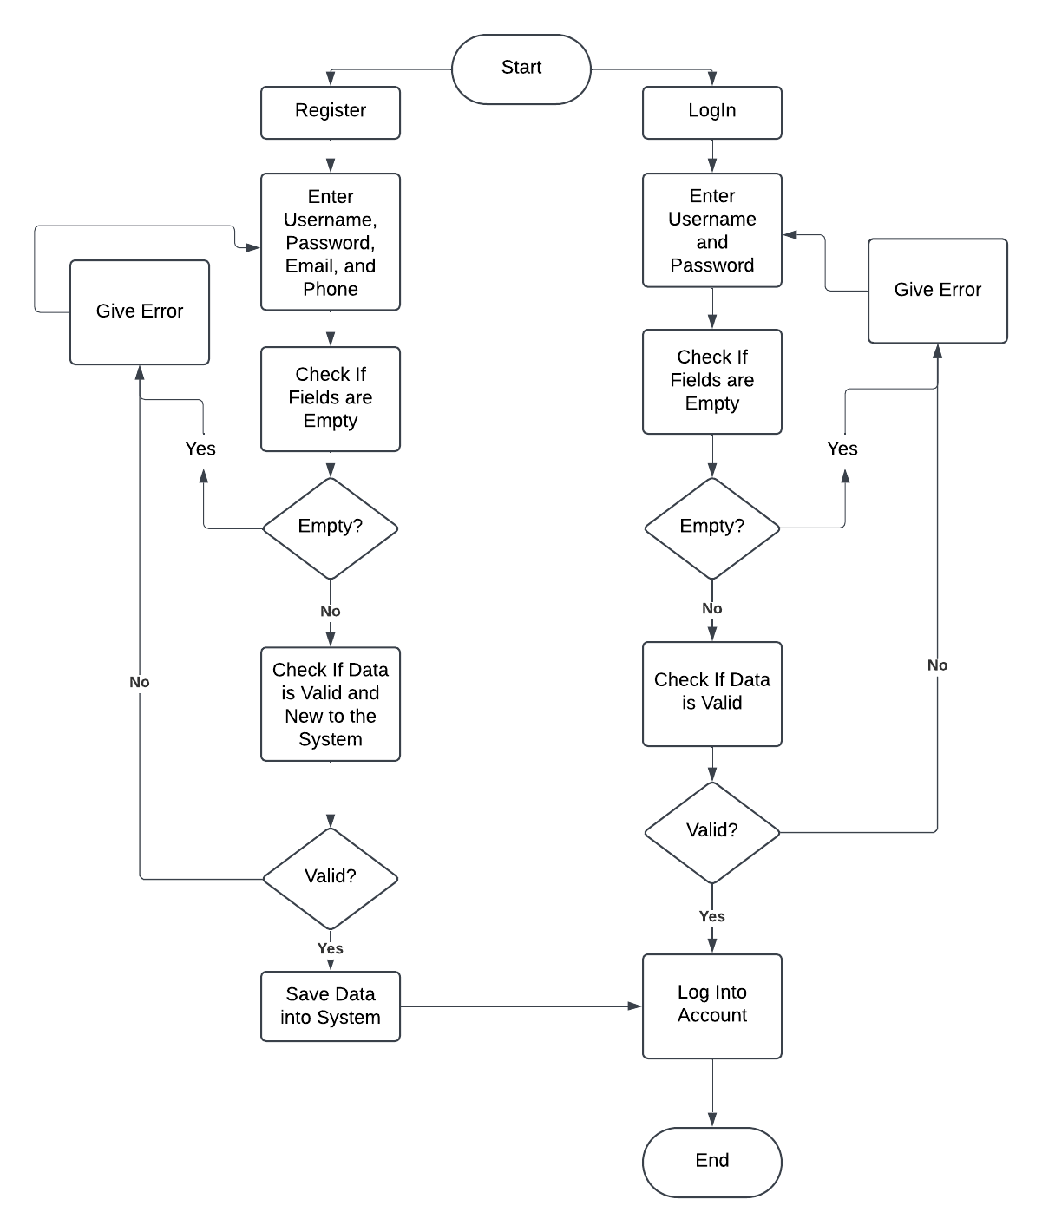Figure 1 Login and Registration Validation Schema

## Diagram of the project’s database

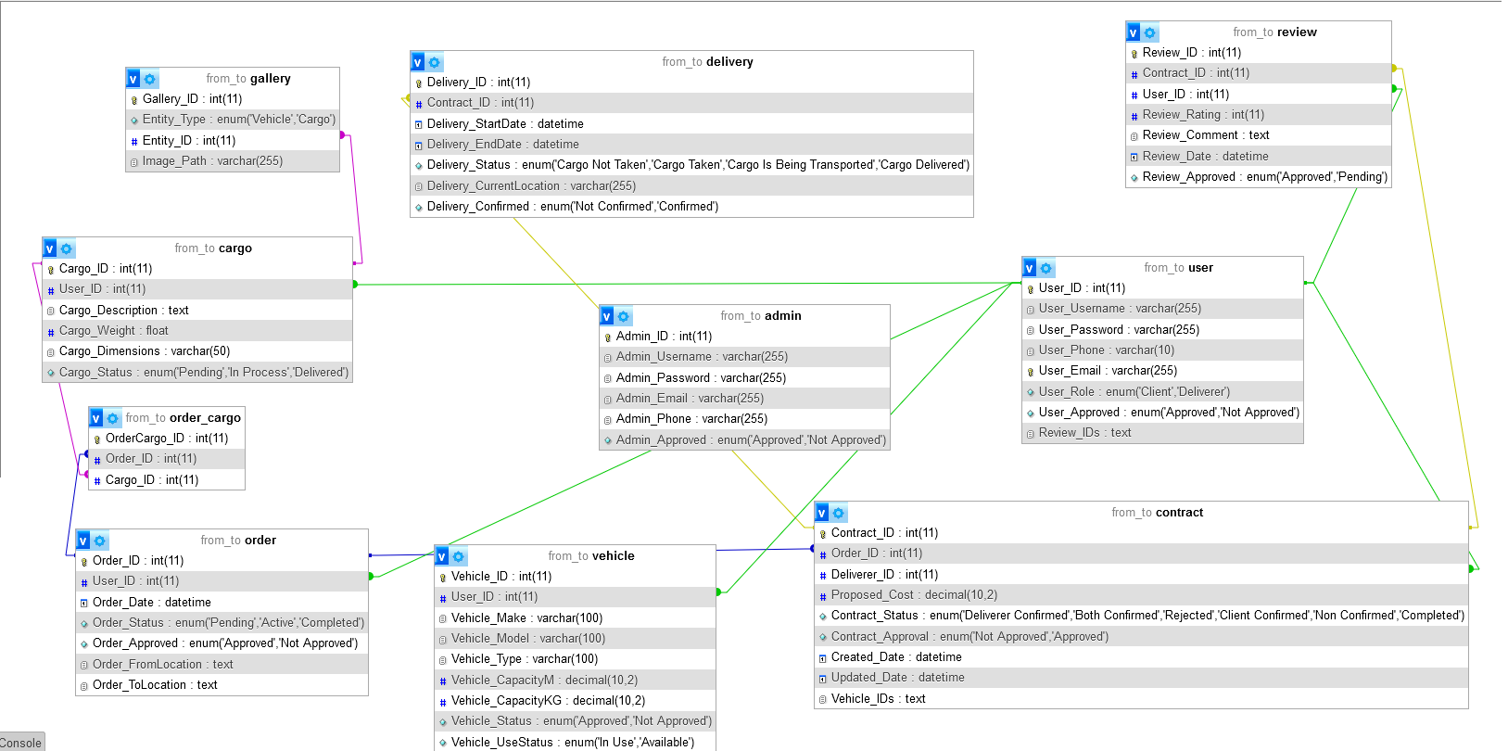

### *Figure 2* Login and Registration Validation Schema

In order to accommodate for the project’s needs, the database that I created for the purposes ended up having 10 tables: 9 regular, and 1 intermediary.

The first table that I created was the Admin table. The Admin table serves as the collection of the login credentials and account details of the Admins. The table includes an Admin_ID, which is set to auto-increment, whenever a new admin is added into the table. Even though the admin’s id key is not included as a foreign key in any of the tables, the admin still serves a distinct purpose, and I wanted to have them in a separate table.

The next table was for the Users. Similar to the Admin, this table collects the details about a user’s profile, such as their telephone number User_Phone, and email User_Email, as well as their role in the project User_Role, whether they have registered as a client or a deliverer, as well as an auto-incrementing User_ID. Based on this distinction, the functionalities of the website with which the user is presented, will vary. There is also a column for Review_IDs, which will collect the IDs of the reviews concerning a user (deliverer), so that an average score can be made.

The next table on the list is the Cargo table. Whenever a user is logged in as a client, they can add instances of Cargo, which will then be combined into an order. When adding Cargo, the user will be able to specify the cargo’s description Cargo_Description, the cargo’s weight in terms of kilograms Cargo_Weight, the cargo’s dimensions in terms of cubic meters Cargo_Dimensions, and an image for the instance of the cargo, which will be collected in the Gallery table, which will be explored later. Whenever a user is adding cargo, their User_ID will be added to the instance of Cargo as a foreign key, and the primary key Cargo_ID is auto-incrementing.

The Order table serves for the collection of the details about the orders, formed by the instances of cargo. The Order_ID auto-increments with the addition of an order. The Order table includes the ID of the user that made it as a foreign key User_ID, the order’s date of creation Order_Date, the Order’s status Order_Status, whether it is pending and without a contract, active with a contract, or already completed, Order_Approved which tracks if the order is approved by an admin, and finally the supposed starting and final locations of the order Order_FromLocation, Order_ToLocation.

The Order and Cargo table are connected by an intermediary table called Order_Cargo, which stores inside it the IDs of the cargo and orders, matching them so that it is easier to track what cargo an order contains.

The next table on the list is the Vehicle table. When a user (deliverer) adds a vehicle, an auto-incrementing ID Vehicle_ID is added, as well as the User_ID (of the deliverer) as a foreign key. The Vehicle table includes details about a vehicle such as its make Vehicle_Make, model Vehicle_Model, type of Vehicle Vehicle_Type, its capacity measured in kilograms Vehicle_CapacityKG, its capacity measured in cubic meters Vehicle_CapacityM, its status Vehicle_Status that tracks whether the Vehicle has been approved by an admin, and the Vehicle_UseStatus, which tracks if the vehicle is currently in use for a contract.

The Contract table collects information about the contracts made by a client and a deliverer. When the two agree on a contract, an instance of Contract is added with an auto-incrementing Contract_ID, the Order_ID of the order for which the contract is made and the Deliverer_ID (User_ID) of the deliverer who will carry out the delivery are added as foreign keys. There is also a Proposed_Cost column, which tracks the price for which the order is delivered, Contract_Status for whether both the client and the deliverer agree on a contract or only one of them, Contract_Approved which is about whether the contract is approved by an admin, after the two users have reached an agreement, and Vehicle_IDs which collects the IDs of the vehicles that a deliverer has chosen for the contract.

After a Contract is agreed upon, a Delivery starts, with a Delivery_ID, Contract_ID as a foreign key, so that it is clear for which order the delivery is, Delivery_StartDate and Delivery_EndDate, Delivery_Status, which the Deliverer will be able to update, e.g. if the cargo has been taken and is on the way, and Delivery_Confirmed which tracks if the user (client) has confirmed the successful completion of the delivery.

After the Delivery is completed, the client confirms its completion and they can leave a review for the service. These reviews are stored in the Review table. It contains the auto-incrementing Review_ID, foreign keys for the contract which was completed Contract_ID, and the user who posted the review User_ID, the rating of the user’s review Review_Rating, the comment of the review Review_Comment, and the date on which the review is posted Review_Date. In order for the review to show up on the website, it first has to be approved by an admin, who changes the Review_Approved row.

The final table is the Gallery, which includes the images that the users are posting of the cargo and vehicles. The gallery stores the images based on the type (cargo or vehicle) Entity_Type and the ID of the thing the image is for Entity_ID, and it has a column for the path to the image, so that the website can find it and load it.

## Description of Application’s Software Architecture and Algorithms

The architecture of the project’s software is contained inside around 20 php files. Each file serves a distinct purpose. Some are primarily focused on interface and presenting the functionalities of the project in a visual way. Others contain some of the logic behind the operations of the project. And the last and largest group are php files that contain both the logic and interface in themselves.

Beginning with the pages that serve a mostly visual purpose, as they will be easier to explain, and showcase the overall structure of the webpages.

### Index and About Pages

The first page that the visitors of the project’s website will be greeted by is the index.php. In terms of structure, the webpage contains a banner, containing a mock-up name for the project “From-To”. Below the banner is the navigation menu, further below is the main content part of the page, where the greeting message will appear, alongside two buttons which send the user to a client’s view or a deliverer’s view, depending on the choice. Finally, there is a footer, containing my name. Pretty simple start whose purpose is to allow the user to either join as a deliverer, or a client.

The next primarily visual webpage is the About.php page. It maintains the overall same structure as the index page, and its contents are just text, which informs the user of the website’s purpose. The only place a user can go to from the about page is back to the index page, where they will once again be presented with the choice of either continuing as a deliverer, or as a client.

### Client Login and Registration

Going back to the index page, let’s say that the user presses the button to continue as a client. They will move on to the Client_LogReg.php page. The page presents to the user a form, which will change according to their needs via two buttons above the form, which change it into a login form or a register form, depending on the pressed button. The default for is the login one and it is the one that the user will see when deciding to continue as a client. The way the switching between the forms happen is through a script, which populates a sort of form container with either html for the login form, or for the registration form

Now, once the user has decided whether they want to login or register, they can populate the form with their credentials, their input will go through validation to check if the credentials are correct, if they are trying to login, or to avoid duplication, in case of registration, for example checking if the inputted username appears in the database:

This validation happens in either ClientLoginCheck.php if the user is trying to login, or in ClientRegisterCheck, if the user wants to register. The purpose of these two files/pages is to make sure that the user’s input is correct, and if it isn’t, to return to the user the errors that they have made, while trying to login or register. For the login, the validation checks for matches against the database for the combination of username and password, while the register file checks if certain credentials that the user wants to have are valid or not, e. g. if they already appear in the database.

If the user successfully passes through the registration or login check as a client, they will be brought to the LoggedIn_Client.php. Overall, the LoggedIn_Client page is similar in look to the index and about pages, as it contains only static content inside it, serving only as a gateway to the functionalities of the client role, which are done in the other pages, accessible by the navigation menu. The navigation menu includes buttons for the home page (LoggedIn_Client.php), the My Cargo page (Client_MyCargo1.php), My Profile page (Client_MyProfile.php), and a log out button. This navigation structure is the same across all the different client pages.

### Client’s My Orders Page

The Client_MyCargo1.php page/file is one of the two largest files/pages in the project. When viewing the page, clients are presented with the Cargo/Orders Dashboard. The dashboard is split into 6 main sections.

The topmost section is the Current Deliveries, as it is the one that probably concerns the client the most. The current deliveries section presents to the user those contracts that have a delivery entry attached to them. The purpose of this table is to allow the clients to track their deliveries in progress, giving them information about how the cargo is going. The table in which the deliveries are shown has columns for Contract ID, Order ID, Proposed Cost, Status of the contract, Status of the delivery, whether the cargo is taken, on its way, or already arrived. If the status of the delivery is that the cargo has already arrived, the client will have the option to confirm this via a button, which is next to the row in the table. The button only appears if the status of the delivery is that the cargo has reached its destination.

The second section tracks the contracts of the client. More specifically, it shows to the client the contracts which do not have an active ongoing, or a completed delivery, since those are already shown in the previous current deliveries section. What the table shows instead are contracts with the contract status of having been approved by both the client and a deliverer. This means that both of them have reached an agreement for the cost of the delivery. What they are waiting for now is the approval of the admin, since a contract needs to be approved by the admin in order for a delivery to start. The other type of contracts that are shown here are the contracts that have the contract status of being approved by the client. These contracts obtain this status whenever the client is the one proposing the contract, or if the client haggles for a contract, proposed by a deliverer, and sends them another deal, basically the same contract, but with a different price tag. The contents of this table are static, and serve only a visual and informative purpose, the tables below it are the ones where the interactivity happens.

The third section is the one for Pending Contracts. This means that it shows the offered contracts that the client has received from deliverers, so the Contract_Status is “deliverer confirmed”. Basically, the client has posted an order, a deliverer has taken them up on that order and has sent a contract, and now it is up to the client to decide what to do with that contract. Another case where a contract would end up in this section is if the client themselves has contacted a deliverer with a contract proposition, but the deliverer has decided that the proposed cost is too little, and has returned the contract to the client with the new price. In both cases, it is now up to the client to decide what to do with the contract, and they are presented with three options: to accept the contract, to reject it, or to try to haggle for a better price with the deliverer. Here’s what happens with each of the three options:

* Accepting the contract: If the client decides to accept the contract, the contract’s Contract_Status becomes ‘Both Confirmed’, which means that both people are happy with the cost, and the contract is sent for approval to the admin. The contract will now show up in the second section of the page with the status column showing that both parties have reached an agreement. Accepting the contract will also delete all other contracts that are still in the process of negotiation about the same order, so that there is only one contract per order by the end.
* Rejecting the contract: If the client decides to reject the contract, the entire contract is removed from the database using the delete sql statement. The order is not removed, however, and neither are other existing contracts for the order, so new and existing contracts can still be made/updated, until the client and a deliverer reach upon an agreement.
* Haggling for a new price: The third and final option that the client has in this section is to try and haggle with the deliverer for a new price. Let’s say that the client posts an order, and a deliverer decides to propose a contract for the order with a proposed cost of $500, and a contract status of “deliverer confirmed”. The client receives the contract in this section, but decides that the price is a bit too high, and through this button, they set a new proposed cost, e.g. $450, and return the contract to the deliverer, to see what they think about the new price. The contract’s status also changes from “deliverer confirmed” to “client confirmed.”

The fourth section of the page is the Current Orders table. What is meant by current orders in this case are orders that do not have a contract that is confirmed by both a deliverer and the client, and have Order_Status “pending.” This means that an order that has a contract for which the client and deliverer are currently haggling for will still appear in this section. What also appears in the table are orders that are currently awaiting approval by an admin, indicating in the table if the approval is still on hold. In case the order is approved, the client will have the option to a Find Deliverers button. This button allows the user to look at what deliverers have the capability of carrying out the order, and works in a couple of steps:

1. First, once the button is pressed, a javascript function called fetchDeliverers() activates with the respective order’s ID as a parameter. This order ID is then sent into a php statement, which via sql will compare which deliverers can take the order.
2. The second step is getting the information about the order, such as the collective weight and dimensions of all the cargo that is included in the order, which is done by joining the Cargo and Order_Cargo tables based on the Order_ID.
3. The next step is getting the deliverers who have available vehicles, and who do not already have a contract for the order, so that only one contract can be made between a client and a specific deliverer. The query that does this also takes into consideration the reviews for the deliverer, if any, as well as the IDs of the deliverer’s vehicles.
4. If the query returns available deliverers, it loops through them, getting the average rating of each deliverer, based on the reviews that clients have posted about them. In case there are no reviews for that deliverer, the variable for the average will have a value of “No Reviews.” Another query in this part looks at the vehicles of each deliverer, and calculates the total carrying capacity both in terms of kilograms, and cubic meters. After this calculation, with an if-statement the program checks if the total carrying capacity of the deliverer’s available vehicles are larger than or equal to the total weight and dimensions of the order’s cargo, in order to determine whether the deliverer can carry out the order. If they can, they are shown in a modal.
   * In this modal, the client will have the option to click on the name of the deliverer, which will open up a table below the name, which includes details about the deliverer, such as their username, phone, and email, as well as their vehicles. This is done through another javascript function called toggleDelivererDetails, which takes the deliverer’s id as a parameter, and returns the User and Vehicle details associated with it.
   * The modal also includes a button next to each deliverer, alongside a field for a proposed cost next to it. The Propose Contract button takes the proposed cost that the client has entered and creates a new contract with it, taking the Order_ID as well, and with a Contract_Status of “Client Confirmed”, sending it to the deliverer that the client has chosen.

The fifth section of the Client_MyCargo1.php page is the Add Order section. The section is represented by a single Add New Order button, which when pressed allows the client to create a new order. The way this works is by opening a modal, whenever the button is pressed. In this modal, the client can set the order’s Order_FromLocation and its Order_ToLocation. Below that the client has access to a form in which they can enter the cargo’s details like description, weight, dimensions, as well as an image if they like. Below that form, there is an Add Cargo button, which will open a new form for cargo, in case the client wants to add more than one cargo to an order. In the actual form for the cargo details, there is also a Remove Cargo button, which will close its cargo form. In case the client closes all cargo forms, they will not be able to submit their order, since they haven’t entered any cargo, so only if at least one cargo form is filled, will the client be able to submit the order. If the client submits the order from the Submit Order button, the code for the button creates an instance of Order in the sql table with the corresponding from-to locations, the date, and sets the order’s status to “Pending”. Then, the code takes the user’s input from the cargo fields and with a loop that goes through the input creates an instance or more in the Cargo table, depending on the amount of forms that the User had filled in, and then those are linked to the Order table by the intermediary table Order_Cargo.

The last section of the Client_MyCargo1.php is the completed orders. This section includes a table, which contains in itself the orders which have an Order_Status “Completed.” The table shows to the user the order’s ID, its date, the description of the cargo inside it, and the username of the deliverer who completed the order, as well as giving the client the option to leave a review for the deliverer’s service. The way the table’s content is gotten is through a query which joins the Order, Order_Cargo and Cargo tables so that the website can show the collective description of the cargo inside the order, then also the Contract and User table for the deliverer’s ID. Then another query goes through the Review table to check if there is already a review for the order, and if there is, shows Review Submitted, but if there isn’t, the user is presented with a Leave a Review button. If the user presses the Leave a Review button, they will be presented with a modal, containing a short form, where they can enter a rating score between 1-5, and a comment, both of which are required for the review to be submitted. When the client successfully submits a review, it is entered into the database by a query which takes the user’s ID, the rating and a comment and creates the instance in Review with Review_Approved being “Pending”, meaning that it is awaiting approval from the admin.

### Client’s My Profile Page

The Client_MyProfile.php page allows clients to manage their account details and view cargo information linked to their account. When the page loads, it confirms the user’s identity and role using session data. If the user is not logged in or isn’t a client, they are redirected to the Unauthorized.php page, but more on that later, since this feature is present on every page which is supposed to be seen when logged in. Once access is granted, the page retrieves the client’s profile details (username, email, phone number) and displays them along with a table of their cargo-related information from the database.

In terms of functionality, from this page users can update their account details directly. Each profile detail, such as username, email, or phone number, has an associated "Change" button that reveals a small form for editing. There is also an option to change the account password, which opens a modal where the user can enter their current and new passwords for validation. Below these settings, the cargo section displays a table listing the client’s cargo items with details like description, weight, dimensions, and order status. If available, cargo images are shown alongside their respective entries. If no cargo is associated with the user, the table simply informs them that no data exists.

### Deliverer Login and Registration

Now let’s consider a similar starting point, but this time for a user who wants to log in or register as a deliverer. Starting from the index page, if the user chooses to proceed as a deliverer, they are directed to the Deliverer_LogReg.php page. This page follows a structure similar to the client counterpart, providing the user with a form that can dynamically switch between a login and a registration mode. The default view is the login form, but the user can toggle between the two using buttons that adjust the form container dynamically through a script. This script updates the container with the appropriate HTML for either logging in or registering.

Once the user decides whether to log in or register, they input their credentials into the form. This input is validated based on the selected operation. Similarly to the part about the client, if the user attempts to log in, their details are validated through DelivererLoginCheck.php, while registration requests are processed via DelivererRegisterCheck.php. The purpose of these scripts is to ensure the input meets the necessary criteria. For logging in, the system checks if the username and password combination matches a record in the database. For registering, the system validates the uniqueness of the entered credentials and verifies that all required fields are properly inputted. For instance, it ensures the username or email isn’t already in use. If the validation fails, the scripts provide error feedback, such as informing the user of incorrect login credentials or identifying which registration fields need adjustment.

Upon successful validation, whether through login or registration, the user is directed to the LoggedIn_Deliverer.php page. This page serves as the deliverer’s main dashboard and has a similar structure to the client’s main page. It features a static content layout and acts as a gateway to deliverer-specific functionalities via a navigation menu. The navigation menu includes the links to the Home page (LoggedIn_Deliverer.php), the Offers page (Deliverer_Offers1.php), the My Profile page (Deliverer_MyProfile.php), and the LogOut button. This navigation remains consistent across all deliverer-related pages, ensuring a familiar user experience throughout their workflow.

### Deliverer’s Offers Page

The Deliverer_Offers1.php page/file is the other of the two largest files/pages in the project. When viewing the page, deliverers are presented with the Cargo/Orders Dashboard. The dashboard is split into 5 parts here.

The first section of the page is, again, for the Deliveries, but it has different functionalities than the client’s. The deliveries are showcased in a table with five columns for the Contract ID, for which the delivery is, the Cost of the delivery (the final Proposed_Cost), the Current Location of the delivery, the Status of the delivery, and an Update button. The way the table is populated is through a query, which joins the Contract table and the Delivery table, so that the deliverer can be presented with details about both, especially since the deliverer will be able to update the status of the delivery. By pressing the Update button, the deliverer will be able to update the status of the delivery from 4 conditions: “Cargo Not Taken”, “Cargo Taken”, “Cargo is Being Transported”, and “Cargo Delivered”. Alongside this, there is a field where the deliverer can input the current location of the delivery. There aren’t set inputs here, the deliverer can enter whatever. When the Update button is pressed, the deliverer’s input made up of the Contract ID, new delivery status, and current location—is submitted. If the selected status is "Cargo Delivered", some additional steps are triggered to finalize the delivery:

1. Updating the Delivery Table: The delivery record is updated to reflect the new status and current location. If the status is "Cargo Delivered", the system also records the delivery's completion time by updating the Delivery_EndDate field with the current timestamp (NOW() in SQL). This ensures that the database correctly records when the delivery was finalized.
2. Updating the vehicles used for the delivery: If the delivery status is set to "Cargo Delivered", the system retrieves the list of vehicles associated with the contract. This is done by a query on the Contract table, which contains the Vehicle_IDs field. Since the field stores the IDs of vehicles used in the delivery, as a comma-separated list, the code retrieves the IDs split into an array of individual vehicle IDs. For each vehicle in this list, the system updates the Vehicle_UseStatus field in the Vehicle table, marking them as "Available". This step ensures that vehicles tied to the completed delivery are freed up for future use.

The second section of the deliverer’s interface tracks contracts relevant to their role. Specifically, it displays contracts that either await admin approval or are pending further action from the client. These contracts have already been agreed upon by both the deliverer and the client, with a finalized cost. However, they remain pending because all contracts require admin approval before a delivery can officially begin. These entries serve as a visual indication to the deliverer that no further action is needed on their part at this stage. Much like the client’s view, this section is static and does not offer direct interactivity. Its purpose is to give deliverers a clear understanding of their current standing with contracts that are in progress but not yet actionable (e.g., pending admin approval). Below this section, additional tables handle the interactive aspects, such as enabling the deliverer to respond to client proposals, negotiate further, or finalize their acceptance of a contract.

The third section is the one for Pending Contracts, same as the one in the client view. Again it shows the offered contracts that the deliverer has received from clients, so the Contract_Status is “Client Confirmed”. This means that the client has contacted the deliverer with a contract directly, instead of waiting for a deliverer to do the first step. On this side, now it is up to the deliverer to decide what to do with that contract. How a contract could also end up it this table is if the deliverer originally contacted the Another case where a contract would end up in this section is if the client themselves has contacted a deliverer with a contract proposition, but the deliverer has decided that the proposed cost is too little, and has returned the contract to the client with the new price. In both cases, it is now up to the client to decide what to do with the contract, and they are presented with three options: to accept the contract, to reject it, or to try to haggle for a better price with the deliverer. Here’s what happens with each of the three options:

* **Rejecting the Contract:** When the deliverer chooses to reject a contract, the system processes this by completely removing the contract from the database. In the background, the application captures the ID of the contract, which is sent via the form submission. The backend code prepares a DELETE statement targeting the specific contract and executes it, ensuring the record is erased from the Contract table. This action is final, since if a contract is rejected, it can no longer be recovered or revisited. However, this operation does not affect the associated order or any other contracts related to that order. After the deletion is complete, the deliverer is redirected back to their offers page, refreshed to show the removal of the rejected contract.
* Haggling: When the deliverer chooses to haggle, they initiate a process that allows them to propose a new price for the contract and assign the vehicles that they want to fulfil the order with. Upon pressing the Haggle button, the backend retrieves and prepares all the details about the selected order and the vehicles owned by the deliverer. This includes loading the order’s total weight, dimensions, and the proposed cost, alongside a list of available vehicles. This information is presented in a modal, which serves as the interface for haggling. The deliverer can input a new proposed cost and select vehicles to assign to the contract. In the background, when the deliverer submits their new proposal, the system performs several validations. The selected vehicles are checked to ensure their combined weight and dimensional capacities meet or exceed the order’s requirements. If the vehicles do not meet these requirements, the system prevents submission and notifies the deliverer of the issue. If the vehicles and proposed cost are valid, the backend updates the contract in the database. The contract status is changed to "Deliverer Confirmed," reflecting the new proposal. Additionally, the vehicle assignments are updated, and the Vehicle_IDs field in the Contract table is populated with the IDs of the selected vehicles. Once the contract is updated, the deliverer is redirected back to the offers page. The page now displays the modified contract in the table above, showing that the deliverer has proposed a new cost, which is pending the client's response.
* When the deliverer decides to accept a contract, it means that there is a final agreement on the proposed by the client cost. In the backend, the system ensures that all conditions are satisfied before proceeding. The deliverer must assign vehicles to the contract. These vehicles are checked for availability and validated to ensure they can handle the order’s weight and dimensions. If the validation succeeds, the contract status is updated to "Both Confirmed," indicating mutual agreement between the client and the deliverer, moving the contract to the table above. In addition to updating the contract status, all other contracts associated with the same order are deleted, ensuring only one contract per order remains. Conflicting contracts involving the selected vehicles are also removed to prevent duplicate or overlapping assignments. Vehicle statuses are updated to "In Use," reflecting their new role in fulfilling the accepted contract. Finally, the order status is set to "Active," signaling the potential start of the delivery process. After these updates, the deliverer is redirected back to the offers page, where the finalized status of the accepted contract is now visible in the second table

The fourth segment of the page presents a table with the orders posted by clients, which the deliverer could carry out. How the project gets these orders is by retrieving “available” orders and calculating their vehicle capacities. The deliverer can see a list of **pending orders** that fit within their available vehicle capacity limits, which are based on available vehicles. The available vehicle capacity is fetched from the database by checking the deliverer's vehicles marked as "Approved" and "Available." Once the capacities are determined, the system filters the orders to show those that are eligible for the deliverer to propose a contract. When the deliverer clicks the **Propose Contract** button, they are presented with a **modal window** containing details about the order, such as the Order ID, Order Date, Total Weight, and Total Dimensions. The modal also allows the deliverer to input a proposed cost for the contract and select vehicles that they wish to assign to the order. The vehicles are displayed as checkboxes, where the deliverer can choose which vehicles to allocate to the order based on the capacities of each vehicle. After submitting the proposed contract details, the backend processes the data. The proposed cost, selected vehicles, and other necessary details are stored in the database, and a **new contract record** is created with the status "Deliverer Confirmed." The contract is now in the database, but it is still not finalized. The deliverer will be able to see the contract under their offers, but it will not be confirmed until the client accepts it. At this stage, the system also checks for any **existing contracts** associated with the same order to prevent conflicts or duplicate contract proposals. If a contract already exists for the same order with the status "Deliverer Confirmed" for the same deliverer, it will be excluded from the list of available orders. The system then responds to the deliverer’s actions by showing feedback through status messages. Once the contract is successfully proposed and stored in the database, the deliverer is redirected back to the **offers page** where they can track the status of their proposed contracts.

The final section of the Deliverer_Offers1.php is the Completed Deliveries table. The table displays several key pieces of information about each delivery: the **Contract ID**, the **Proposed Cost** of the delivery, the **Current Location** of the delivery, and the **Status** of the delivery. Each row in the table represents a completed delivery, and the data is dynamically populated from the results of a SQL query. In the back-end, the query retrieves all completed deliveries that match the user's account, filtering the data based on the **contract status** and delivery details. If there are any completed deliveries, the data is formatted and shown in the table. If no completed deliveries are found, the user sees a message indicating that no deliveries have been completed yet. Each row of the table is filled with the corresponding **contract ID**, the **cost** associated with the contract, the **current location** of the delivery (if available), and the **delivery status**. The **delivery client-confirmed** status is also displayed, indicating when the delivery was officially confirmed by the client as well as the deliverer.

### Deliverer’s My Profile Page

The Deliverer_MyProfile1.php page allows clients to manage their account details and view the vehicle information linked to their account, add new vehicles, and see the reviews written about their service. The deliverer can view and update their personal account information on the profile page. When the page loads, it retrieves the current details (such as username, email, and phone number) from the database, using the session’s User_Username to identify the correct user. Each piece of profile information is displayed along with a "Change" button. When clicked, this button reveals a small form where the deliverer can edit the information. Upon submitting the form, the changes are saved in the database using a secure SQL update query. If the update is successful, the page will display a confirmation message, and the updated details will be shown on the profile page.If the deliverer wants to update their password, they can click the "Change Password" button. This opens a modal where the deliverer must first enter their current password, then their new password, and confirm it by entering it again. The system checks if the current password is correct by comparing it against the stored hash in the database. If the current password matches, and the new password is valid (e.g., meets length and complexity requirements), the password is updated in the database. A confirmation message is displayed, and the user is logged out automatically to ensure security. If any of the password fields are incorrect or invalid, an error message is shown. The deliverer can view their associated vehicle details on the same page. This section displays a table of all vehicles linked to the deliverer's account. The vehicle’s details, such as make, model, type, capacity, and current status (e.g., "In Use" or "Available"), are listed. If the vehicle is not currently in use, the deliverer can click the "Change" button next to each vehicle to edit its details. Clicking the button opens a modal where the deliverer can update the vehicle’s information or upload a new image. Once the form is submitted, the database is updated, and the vehicle details on the page are refreshed. If the vehicle is marked as "In Use," the "Change" button is disabled to prevent editing while the vehicle is actively assigned. If the deliverer no longer wishes to use a particular vehicle, they can delete the vehicle from their account. Deleting a vehicle removes its details from the database using a delete SQL query. The system ensures that only vehicles marked as "Available" (i.e., not in use) can be deleted. If a vehicle is successfully deleted, the table is updated, and the deliverer is notified that the vehicle has been removed. However, if a vehicle is "In Use," it cannot be deleted, and the user will see an error message explaining that only available vehicles can be deleted. The deliverer also has the option to add vehicles by clicking the "Add Vehicle" button, which triggers a modal dialog. The modal contains a form with multiple fields for entering the vehicle’s information, such as make, model, type, capacity in cubic meters and kilograms, and an option to upload a vehicle image. When the form is submitted, the data is sent to the server using the POST method, with the form also including a hidden field (name="addVehicle") to indicate that a new vehicle is being added. The image file, if the deliverer has decided to upload one for the vehicle, is handled via the enctype="multipart/form-data" attribute to allow file uploads. Once the vehicle and image have been successfully added, the script redirects the user back to the profile page (Deliverer_MyProfile1.php) using the header() function to update the page. To retrieve the reviews for the deliverer, the script prepares and executes a SQL query that joins the Review, Contract, and User tables. This query pulls reviews where the Deliverer_ID matches the current session’s deliverer ID and the review is marked as 'Approved'. The bind_param function binds the deliverer's ID to the query for secure execution. After the query is executed, the reviews are fetched into an array ($reviews[]), and the total rating is calculated by summing the individual ratings from each review. The average rating is then computed by dividing the total rating by the number of reviews, and it is rounded to one decimal place. If no reviews are found, the average rating defaults to 0. This data can then be displayed in the reviews section of the profile page. If no approved reviews are available, the table will indicate this with a "No reviews available" message.

### Admin Login and Registration

The process for login and registration for admins is pretty much identical to those of the client and the deliverer. Starting from the Admin-Login-lb1tk2.php page, providing the user with a form that can dynamically switch between a login and a registration mode. The default view is the login form, but the user can toggle between the two using buttons that adjust the form container dynamically through a script.

When the user wants to login or register as an admin, their inputted data goes through a similar process to those of the client and deliverer, it’s just that it is happening in AdminLoginCheck.php and AdminRegisterCheck.php

Upon successful validation of the inputted data, the user is directed to the LoggedIn_Admin.php page. This page serves as the admin’s main dashboard and looks similar to the deliverer’s main page. The navigation menu includes the links to the Home page (LoggedIn_Admin.php), the Orders page (Admin_Orders.php), the Vehicles page (Admin_Vehicles.php), the Reviews page (Admin_Reviews.php), the Accounts page (Admin_Accounts.php), and the LogOut button. This navigation remains consistent across all of the admin’s pages.

### Admin Orders Page

The Admin_Orders.php page shows to the admin all the contracts and orders that need approval, in order for the operations of the project to continue. The orders and contracts are showcased in two separate tables, with details like IDs and current approval status shown, alongside buttons for Approving, Disapproving, or Deleting the contracts/orders. When the admin decides to approve a contract, the contract’s Contract_Approval status is updated to 'Approved', indicating that the admin has given the green light for the contract to proceed. The contract will then be shown with the 'Approved' status in the system. Along with this, a new entry is created in the Delivery table to track the delivery associated with the contract. This ensures that once the contract is approved, the logistics or delivery process can begin. The approval also means that the contract can no longer be edited or canceled unless a further action is required from either party. If the admin decides to delete a contract, the contract is removed from the database using a DELETE query. This action permanently removes the contract record, ensuring that it no longer appears in the system or affects the related order. Deleting a contract does not affect the related order, which can still be processed or have new contracts attached to it. If an order is pending approval from the admin, the admin can approve the order by setting the Order_Approved status to 'Approved'. This signifies that the admin has reviewed the order and has allowed it to proceed. Once the order is approved, it becomes eligible for further steps like contract negotiations or delivery scheduling. The admin can also disapprove an order if they find any issues or discrepancies, setting the status to 'Not Approved'. This flexibility ensures that only valid orders are processed further in the system. When an admin disapproves an order, the Order_Approved status is updated to 'Not Approved'. This action prevents the order from moving forward, and the client or deliverer may need to resolve issues or modify the order before resubmitting it for approval. Disapproving an order ensures that the order does not proceed to the contract stage unless all necessary conditions are met and the admin is satisfied with the details provided. If the admin decides that an order should no longer be part of the system, they can delete the order from the database. This action removes the order entirely, making it unavailable for further contract creation or processing.

### Admin Vehicles Page

The Admin_Vehicles.php page is similar to the page for orders/contracts since its purpose is just to show in a table all the vehicles in the database, so that the admin can decide whether to approve a vehicle for use by a deliverer, or to delete it. The page displays a table of all vehicles currently registered in the system. The table includes information such as the vehicle's username (owner), make, model, type, capacity in cubic meters, carrying capacity in kilograms, and the current approval status. Each vehicle entry also provides two action buttons: one for approving the vehicle (if it is not already approved) and another for deleting the vehicle. The list is generated dynamically by querying the database, ensuring that the admin sees the latest information. When the admin decides to approve a vehicle, the vehicle’s Vehicle_Status is updated to "Approved". This indicates that the vehicle has passed the necessary checks and is now ready to be used in the system. The change is made by submitting a form that sends the vehicle’s ID to the server, where an sql query updates the status of that specific vehicle to "Approved". Once the approval is complete, the page refreshes to display the updated status. If the admin decides that a vehicle should no longer be part of the system, they can delete the vehicle by submitting a form with the vehicle's ID. This triggers an sql query that removes the vehicle record from the database. Deleting a vehicle completely erases its information from the system, ensuring that it no longer appears in the vehicle list or can be used for any future transactions. Similar to the approval process, the page is refreshed to reflect the changes.

### Admin Reviews Page

Similar to the two pages before it in terms of structure, this page serves as a visualizer for the reviews in the database. The page displays all reviews in a table format, including both approved and pending reviews. Each row includes details such as the username of the reviewer, the associated contract ID, the review rating, the review comment, the submission date, and the review's current approval status. The action buttons (approve or delete) are displayed based on the review’s status, allowing the admin to manage each review as needed. Pending reviews can be approved by the admin, while all reviews have the option to be deleted. When the admin decides to approve a review, the review's status is updated to 'Approved'. This is done by updating the Review_Approved field in the Review table. Additionally, the contract associated with the review is checked to retrieve the Contract_ID and Deliverer_ID. If the deliverer exists, the review’s Review_ID is added to the deliverer's profile under Review_IDs. If the deliverer already has reviews, the new review ID is appended to the list; if not, it becomes the first review ID. This process ensures that the deliverer’s profile reflects the newly approved review. After the review is approved and the deliverer's profile is updated, the page refreshes to show the updated status. If the admin opts to delete a review, the review is completely removed from the database. This is achieved by executing a DELETE SQL query that targets the Review table using the Review_ID. After the deletion, the page refreshes to reflect the updated list of reviews, with the deleted review no longer appearing in the table.

### Admin Accounts Page

The final page in the admin’s dashboard is the Admin_Accounts.php page, and it is similar to the ones before it, allowing the admin to approve or delete accounts of the users in the database. The page retrieves and displays all users from the database in a table format. Each row includes the user’s ID, username, email, role, and approval status. The admin can perform actions for each user: approve or disapprove the user, or delete the user. The action buttons (approve, disapprove, delete) are dynamically displayed based on the user’s current approval status, allowing the admin to manage users accordingly. When the admin approves a user, the user's status is updated to 'Approved' in the database. This is achieved by executing an SQL UPDATE statement, which sets the User_Approved field to 'Approved' for the specified User_ID. Once the user's approval status is updated, the page refreshes to show the new status in the table, ensuring that the user is marked as approved. If the admin decides to disapprove a user, the user’s approval status is changed to 'Not Approved'. This is done by executing an UPDATE SQL query that modifies the User_Approved field to 'Not Approved' for the selected user. After the status is updated, the page is refreshed to display the updated information, showing the user’s disapproved status. If the admin decides to delete a user, the user is completely removed from the database. This is done by executing a DELETE SQL query, which deletes the user based on their User_ID. After the user is deleted, the page refreshes, removing the deleted user from the table and updating the list of users.

These are overall all the pages in the project, and what they do, with the exception of one page, which will be explored a little in the next section.

## Security Features and Reliability Considerations

One of the most important reliability and semi-security measures of the project is the Unauthorized.php. Every page that is supposed to be seen only by a specific user implements a check near the top of the php file to see if the user has access to the page, and if not, they are sent to Unauthorized.php, which will redirect the user based on if they have logged in or not. For example, a user that has logged in as a client tries to access LoggedIn_Deliverer.php from the search bar. The check in LoggedIn_Deliverer.php will detect that the SESSION data is that of a client, and will send the user to Unauthorized.php, which will give the option to the user to go back to the client dashboard.

One of the key security measures is the use of prepared statements for database interactions, particularly during user registration. By employing prepared statements with parameterized queries, the code effectively mitigates the risk of SQL injection attacks, which are a common vulnerability in web applications. This way user inputs are treated as data rather than executable code, which providing a strong barrier against malicious attempts that could aim to compromise the database or how the app functions.

Additionally, the project employs strong password management by using password_hash() to store user passwords securely. The hashing mechanism serves to turn plaintext passwords into a secure format that is nearly impossible to reverse-engineer, even if the database were to be compromised. This way, the application ensures that sensitive user credentials remain protected.

When it comes to other reliability considerations, the code takes a systematic approach to error handling and user feedback, so that the project can maintain a stable user experience. The code has numerous checks that validate user inputs at the various stages of the registration and login processes, accumulating errors and presenting them to the user if any issues arise with the filling of the forms. This approach informs users about specific problems with their submissions and it can also guide them about how to fix their mistakes with the filling of the form. Collecting error messages into one array and presenting them at once ensures that users can make all necessary corrections in a single attempt rather than having to submit the form multiple times to address individual errors.

As already mentioned in previous segments of the documentation, upon submission of either the registration or login forms, the app always checks whether or not each field is filled, after which performing specific actions, depending on the type of field and the type of form. For example, whenever a user tries to register, the username that they have inputted gets run through the database and is compared to the existing records, so that no duplicate accounts are created, resulting in error messages for the user if there is a case of duplication, or if the user hasn’t entered anything in the username field.

# **4. Implementation**

## Installation Requirements

* Stable Internet Connection - a stable internet connection is essential to download the necessary platforms and tools, such as Visual Studio Code, XAMPP, and phpMyAdmin. Though once these applications are installed, running the actual project requires no internet.
* Development Environment - **Visual Studio Code (VS Code)**: A text editor with extensions for PHP, MySQL, and debugging. In order to download VS Code, one just has to navigate to the official VS Code website (<https://code.visualstudio.com/Download>), choose their OS, and download the appropriate version. As for the hardware requirements, a minimum 1.6 GHz or faster processor is recommended. VS Code runs well on most modern CPUs, and while higher processing speeds enhance performance, even budget CPUs can generally support it well. At least 1 GB of RAM is needed, though 4 GB or more is recommended for optimal performance. The download size for VS Code is under 200 MB, and it requires less than 500 MB of disk space for installation. No dedicated GPU is necessary for running VS Code, as it does not rely heavily on graphics processing. (<https://code.visualstudio.com/docs/supporting/requirements>)
* XAMPP – Visit the official XAMPP website, select the version compatible with the operating system (Windows, Linux, or macOS), and download the installer. Open the downloaded .exe (for Windows) or equivalent installer file. Follow the setup wizard’s prompts, where you can choose the components to install. (<https://www.apachefriends.org/>)
* phpMyAdmin – Could already come with the installation of XAMPP, but if for some reason it is not there, go to the phpMyAdmin official website and download the latest version. Make sure to select the version compatible with your PHP and MySQL versions. (<https://www.phpmyadmin.net/>) Extract the downloaded .zip file, and place the phpMyAdmin folder in your web server’s directory. For XAMPP users, this will be in the htdocs folder (usually located at C:\xampp\htdocs on Windows).
  + In order to run the project, the .sql file provided in the .zip should be imported into phpMyAdmin. This can be done by going to the Home page in phpMyAdmin and selecting the Import button from the menu at the top. Next, in the field “File to import:” click the “Browse…” button and select the .sql file. After choosing the file, click Import at the bottom of the page.
* The only library used for the project is Bootstrap, which is a CSS framework that was used in the creation of the interface of the project. The library requires no special installation, as it is imported into the pages with a simple script, which is already in the pages.

# **5. Testing**

After the implementation of all the features I originally wanted the project to have, it has reached a state, which is fit for testing purposes. After running some tests, I have found out that the code runs as it should, without any major problems, since the code is implemented in a way that prevents failures. If it so happens that incorrect data is passed to the code, the user will be presented with an appropriate error message, which ensures a smoother experience. To showcase the testing, I will use various screenshots I’ve made during the process, which will include the key features that I’ve captured during the testing process

Credentials used, can also be used for further testing (username/password): admin – admin/parola; deliverer – DELIVERER/del; client – CLIENT/client

Starting from the beginning, here’s the first page that a user will see, when they open the project.

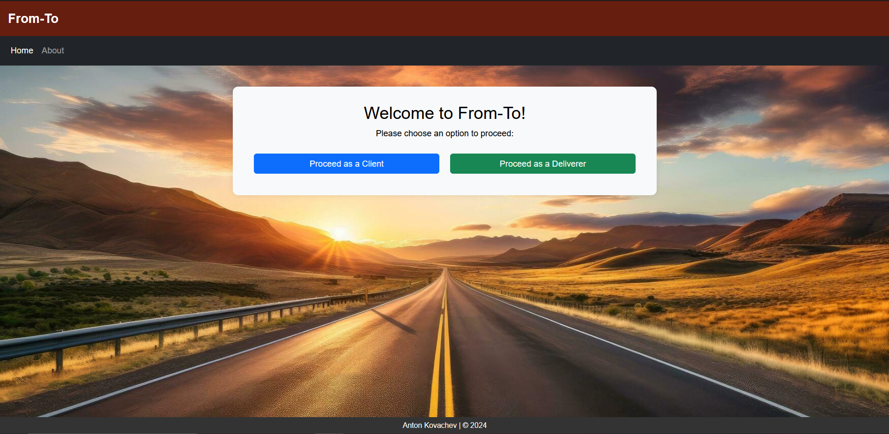

Figure 3 Home Page

From the Home page, the only other non-login/registration page that the user can see is the About page.

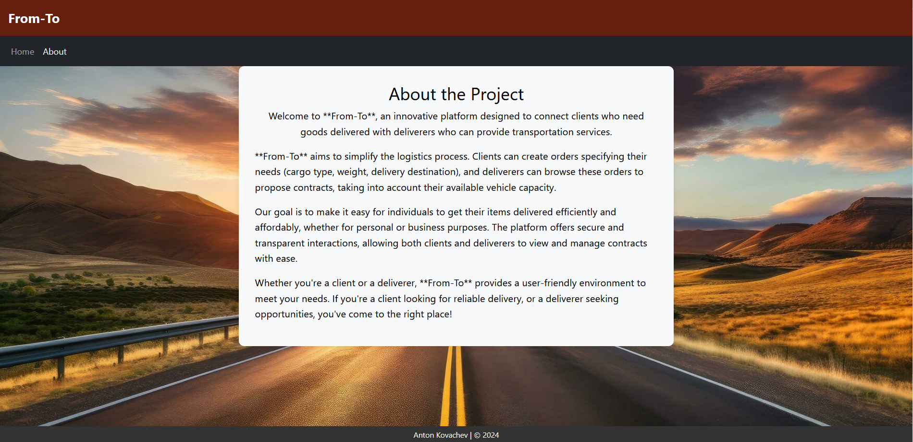

Figure 4 About page

Going back to the Home page, let’s click the button to proceed as a Client and to try to register, but in the field with the password confirmation, I will type something wrong intentionally. I will also use a username that already appears in the database.

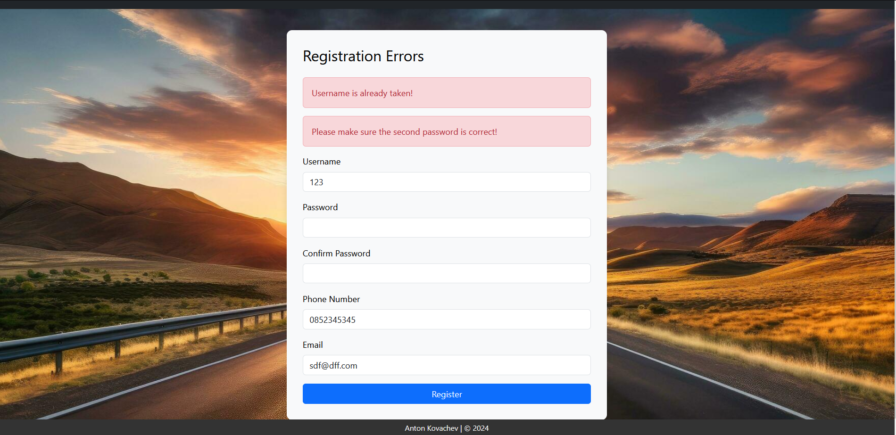

Figure 5 Registration Errors

The user is presented with the corresponding errors, and the form is shown to them again, with the non-password fields containing the previously inputted by the user information. For the sake of the testing, I will create a new Client account with username Client, and a Deliverer account with username Deliverer. After the successful registration as a client, I am greeted with the page for logged in clients.

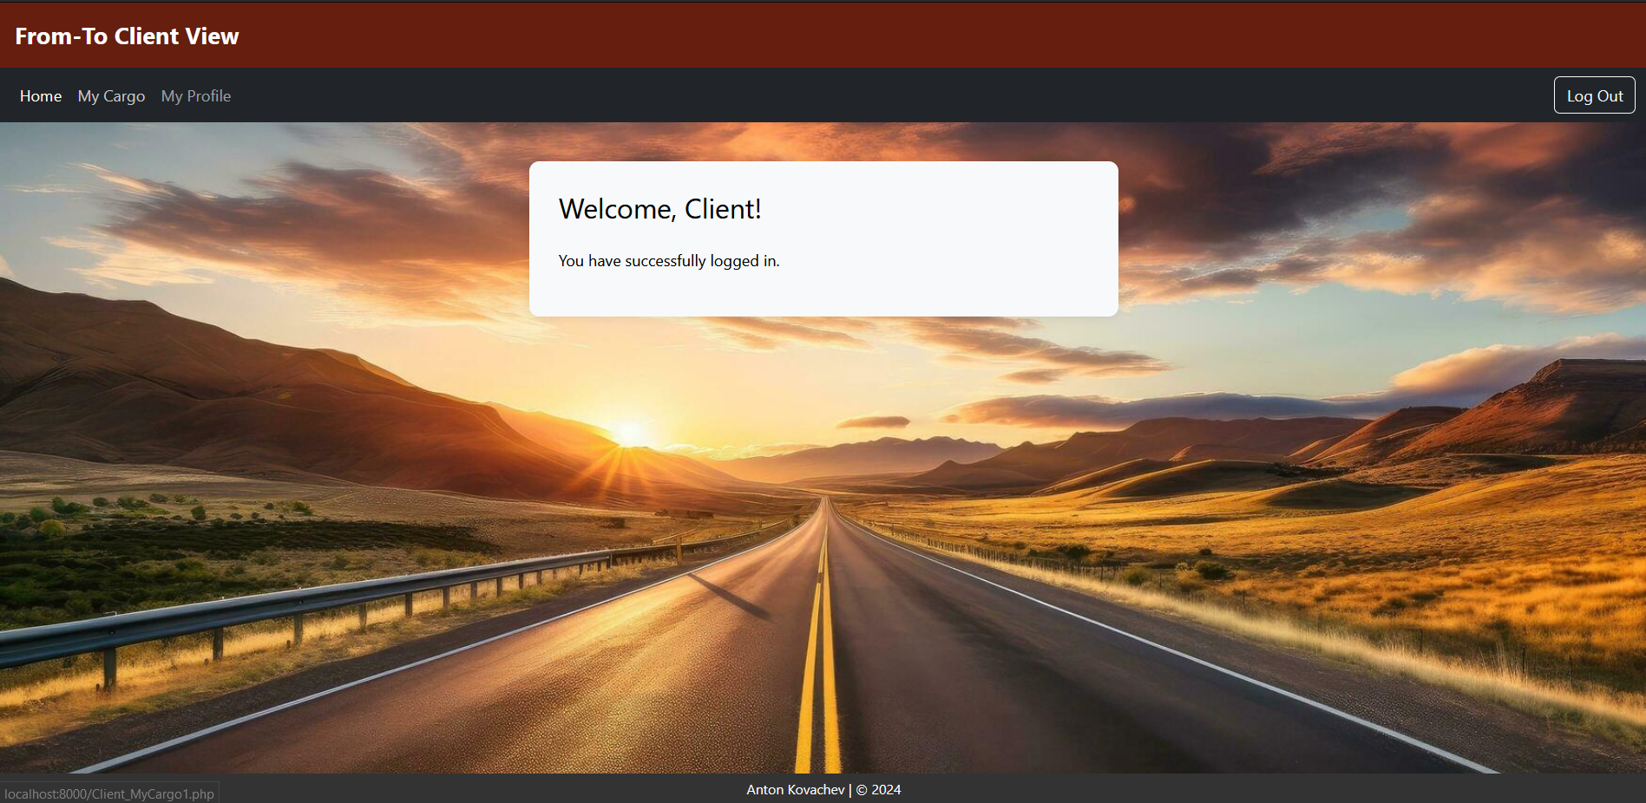

Figure 6 Logged In Client View

Now, the first thing I’ll do as a client is to go to the My Cargo page, and create an order containing two Cargo instances. The first one will be with description Candy, weight 100 kg, and dimensions 20 m3. The second one will be Wood, weight 200 kg, and dimensions 30 m3.

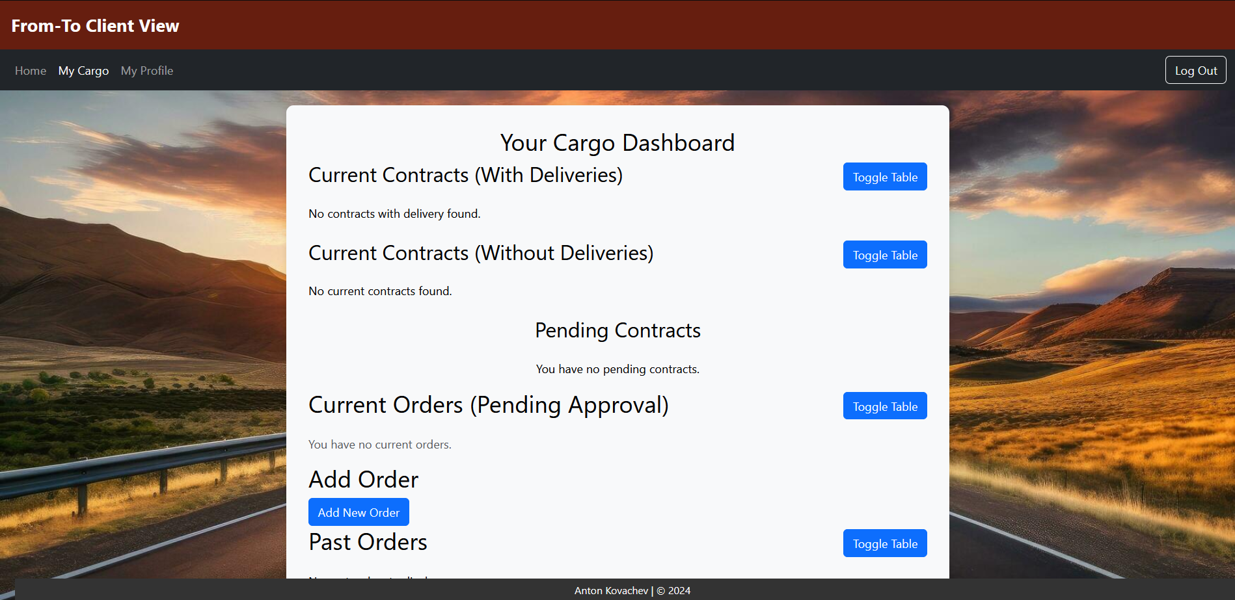

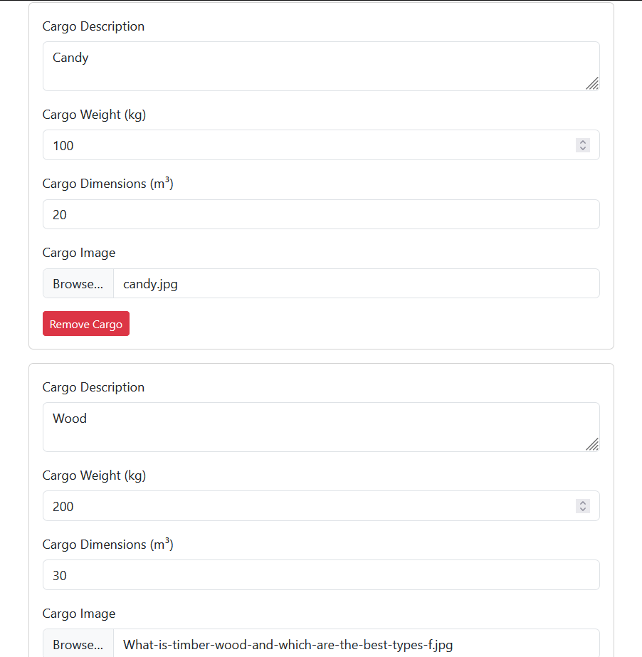

Figure 7 Adding an Order

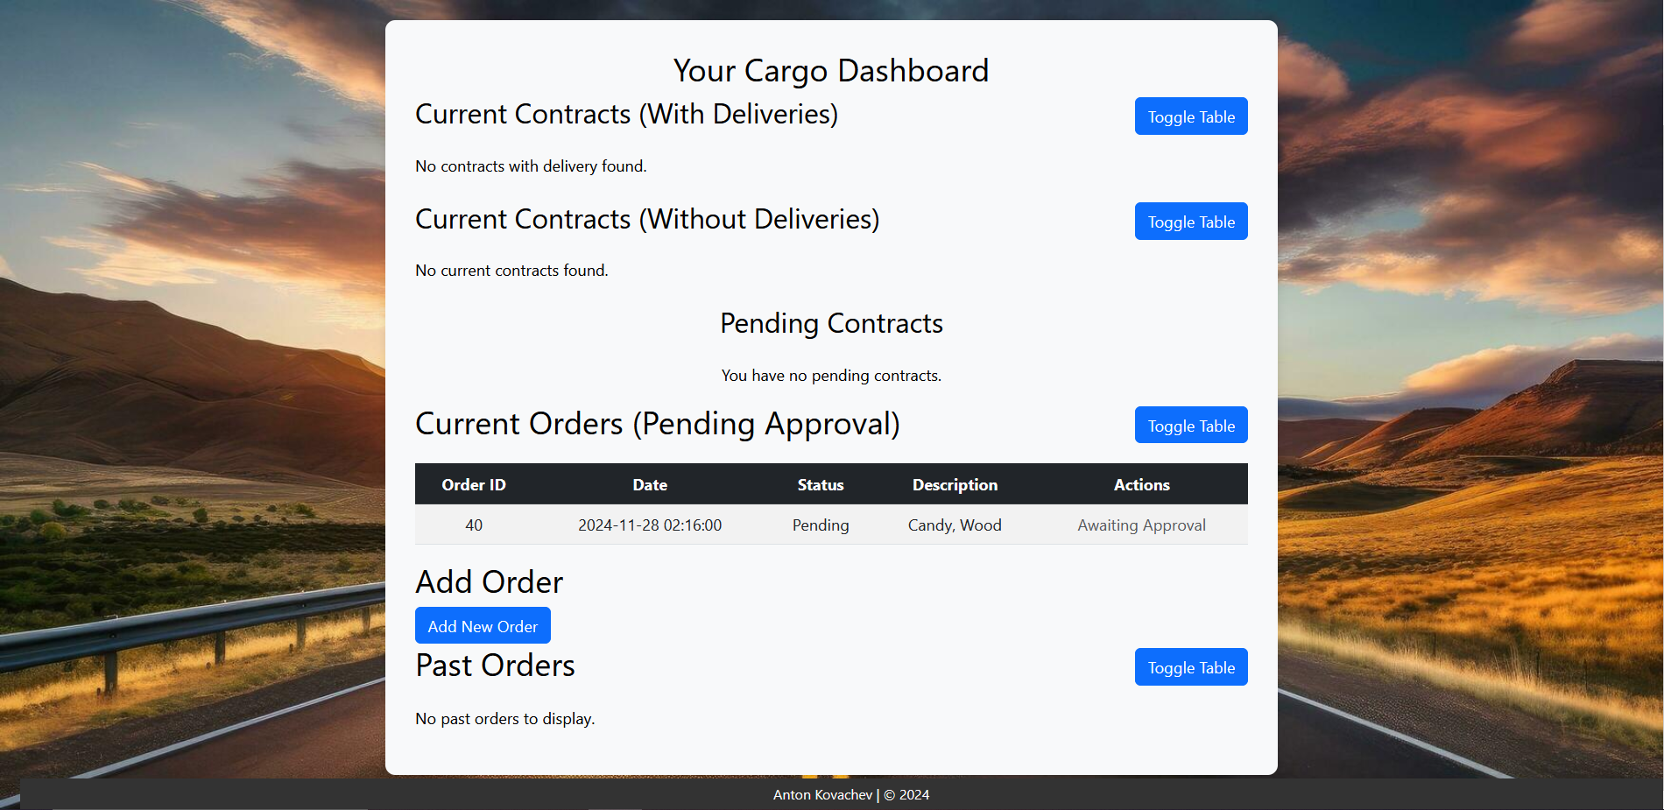

Figure 8 Added Order

Now that the order has been posted, it is visible in the client’s current orders tab, but in order for it to be visible by the deliverers, it needs to be approved by an admin, but I’ll do that at a later stage. For the next part, I’ll move to the Deliverer I created, and add a Vehicle to him.

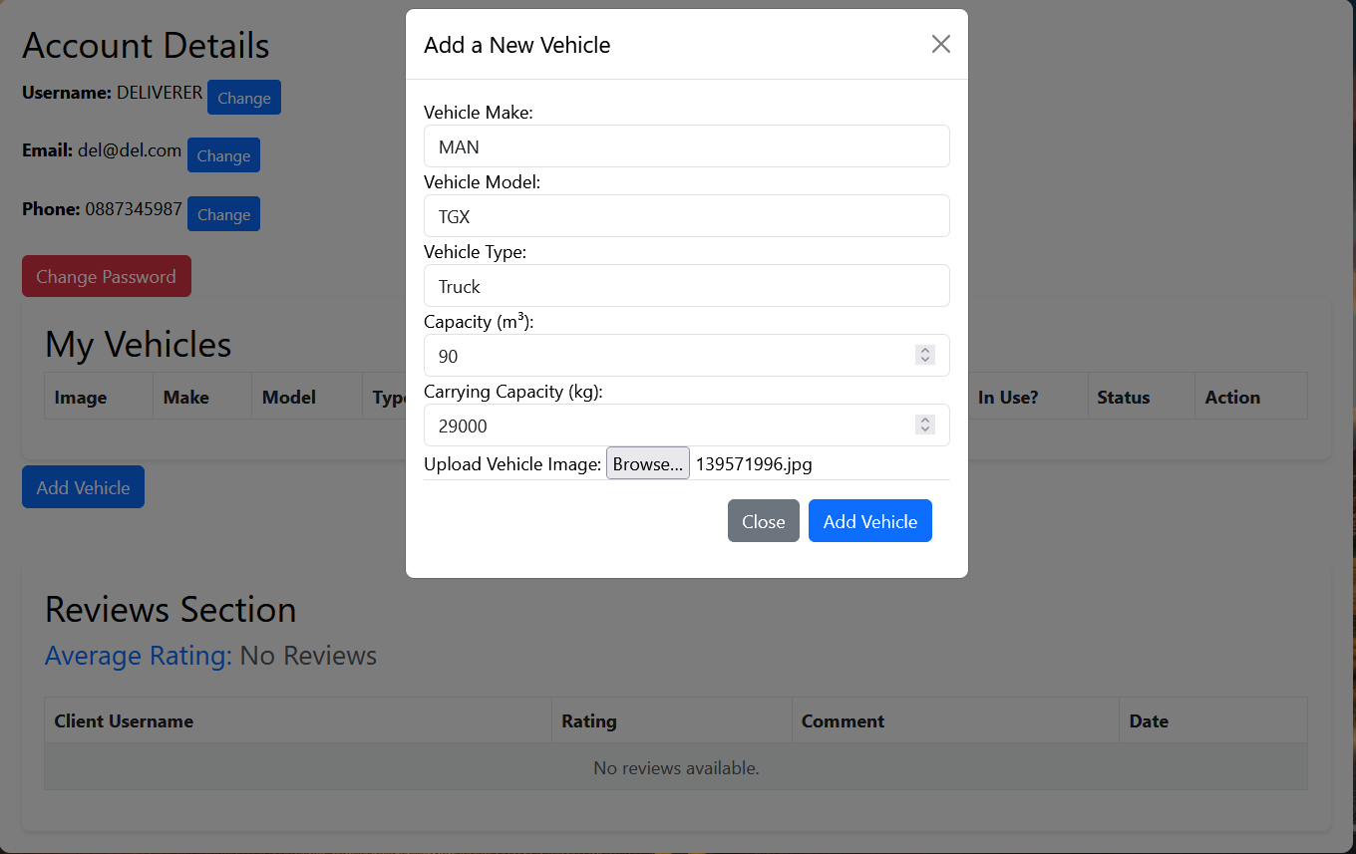

Figure 9 Add a Vehicle

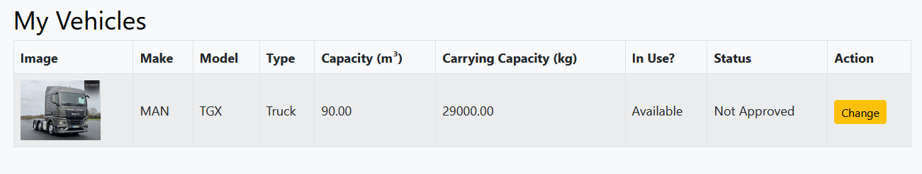

Figure 10 Added Vehicle

The result of the addition is now shown in the My Vehicles section of the Deliverer_MyProfile1.php page. Now, in order to form a contract between the two users, an admin first has to approve the order in Admin_Orders and the vehicle in Admin_Vehicles..

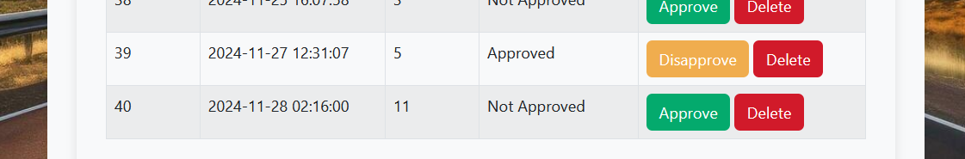

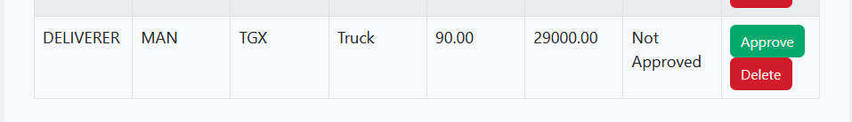

Figure 11 Approving the Order and Vehicle

With both the vehicle and the order approved, I can now test the creation of the contract. For the purpose of testing, I will propose the contract from the client’s side

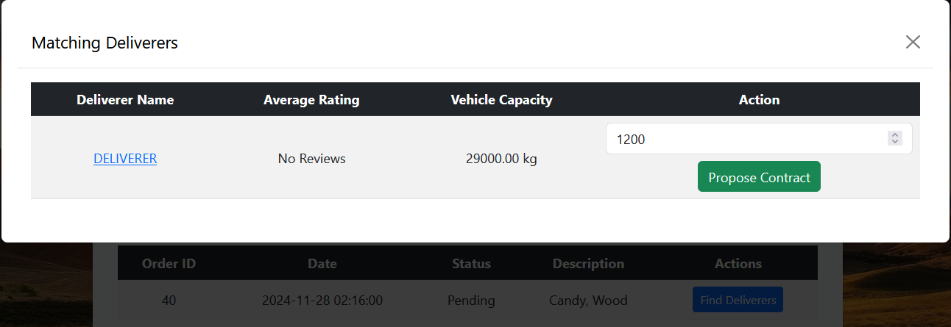

Figure 12 Approving the Order and Vehicle

Since the admin approved the contract, the client has access to the Find Deliverers button in the Current Orders section of the My Cargo page. I will propose the contract to the Deliverer I just added with a proposed cost of $1200. The reason the deliverer is showing up as a match is because the vehicle I added to him has greater carrying capacity than what is required for the order. For the purposes of testing, as the deliverer I will haggle and increase the cost to $1300, select the vehicle for the job, and send the contract back to the client.

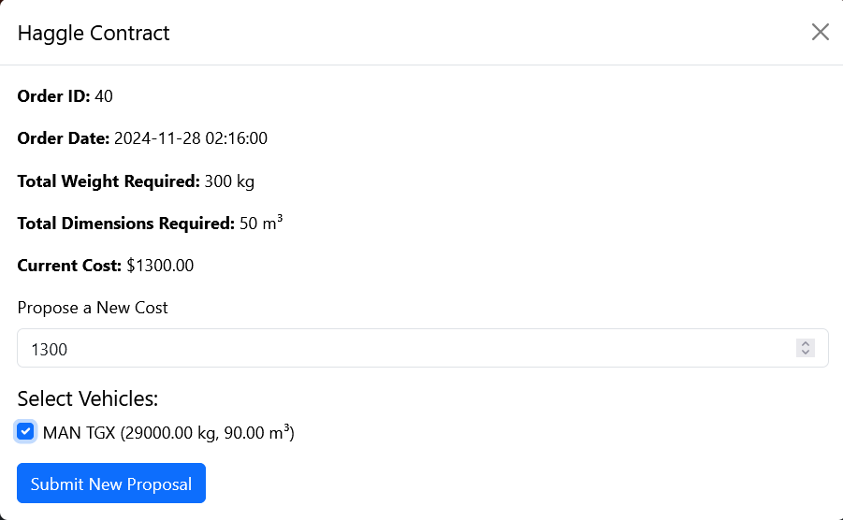

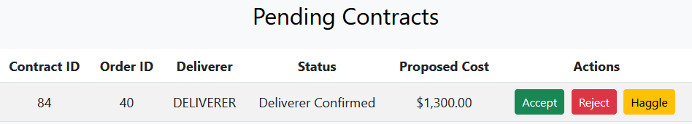

Figure 13 Haggling and Sending the Contract Back

Now it is up to the client to decide whether they will accept the new price, reject the contract, or haggle again for a lower price. For testing purposes, I will accept the contract, so that the program moves closer to a delvery.

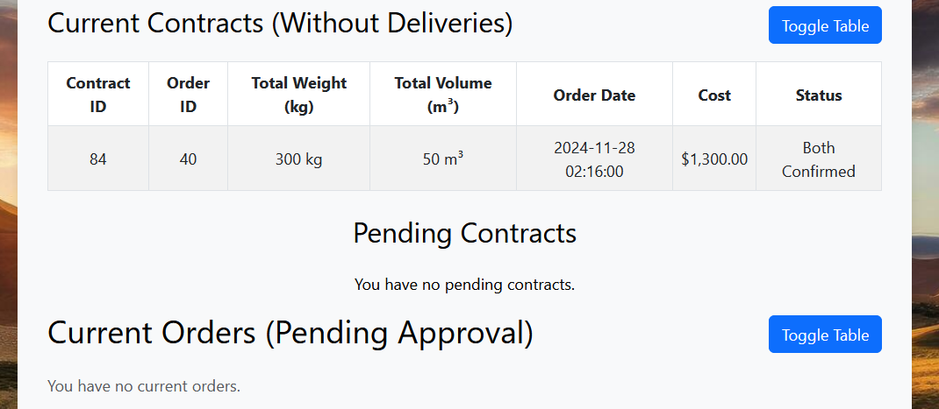

Figure 14 Contract Accepted by Both

By accepting the contract, it’s status now becomes “Both Confirmed”, meaning that it is now waiting for the approval of the admin, so that a delivery can start. Also, by reaching an agreement for a contract, the client now loses the option to look for matching deliverers, since the order has become active. The next step of the testing process will be the approval of the contract by an admin.

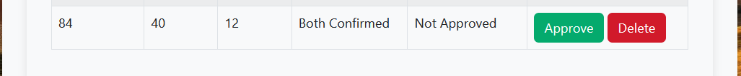

Figure 15 Contract Accepted by Both Confirmation

With this approval, a delivery is started, and the deliverer can make changes to its status, updating the information about the cargo’s whereabouts. For example, setting the status to “Cargo is Being Transported” and setting the Current Location to “Dupnitsa.” These updates are reflected on the client’s dashboard as well.

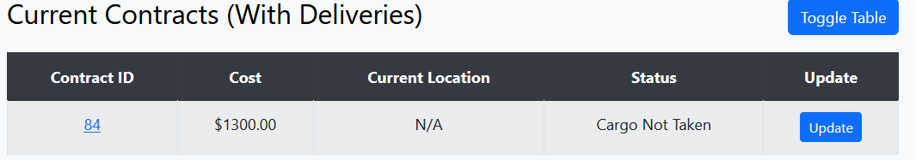

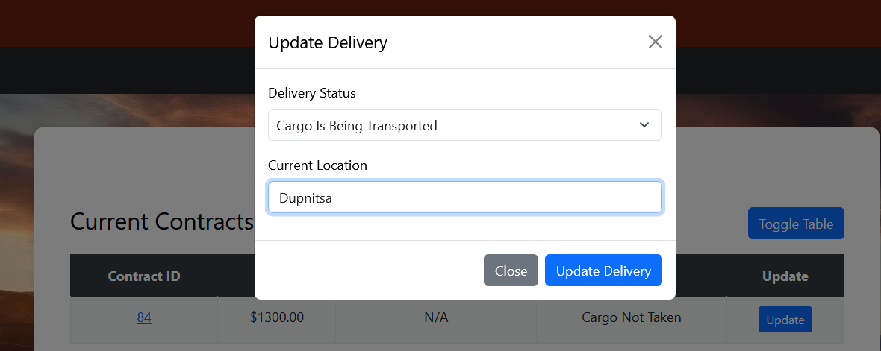

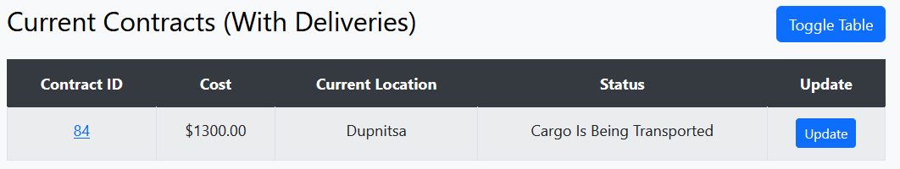

Figure 16 Delivery Update by Deliverer

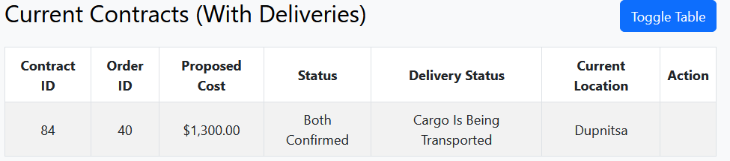

Figure 17 Delivery Details Client View

If the Deliverer sets the delivery status to “Cargo Delivered,” then the delivery is finished and waits for a confirmation on the client’s side. When the client confirms the completion, the contract gets moved to the last section of the dashboard, and the client can leave a review

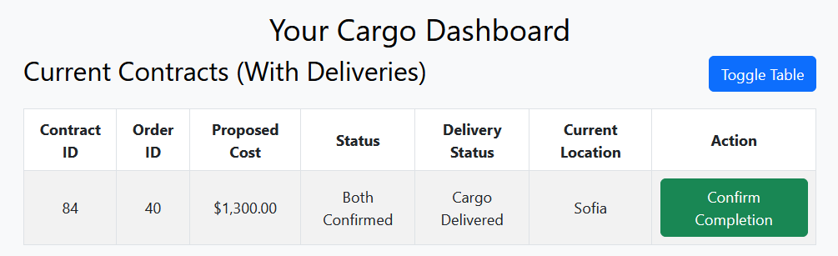

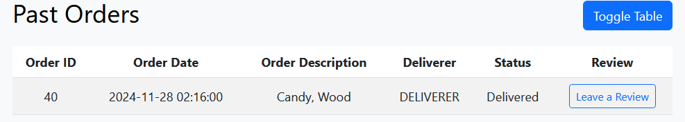

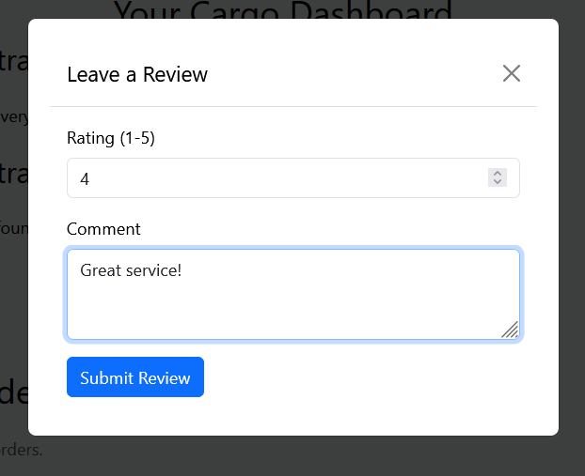

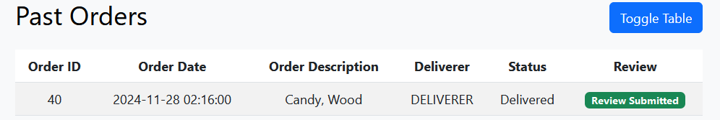

Figure 18 Client Confirming the Completion of a Delivery and Leaving a Review

In order for the deliverer to see this review, it has to be approved by an admin first.

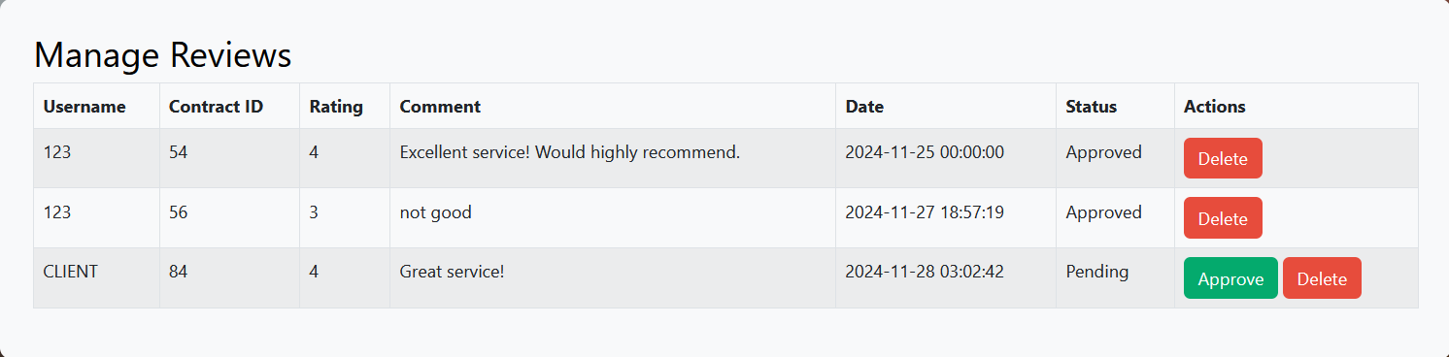

Figure 19 Approving the Review

Once the Review is approved, it will appear on the deliverer’s “my profile” page.

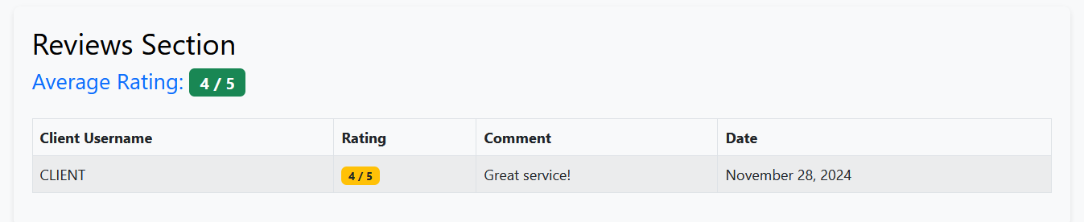

Figure 20 Review on the Deliverer’s Page

# **6. Results and Conclusions**

## Results vs. Initial Hopes

When I first began working on the project, I had a very simple idea of just clients and deliverers sending contracts back and forth to each other, but I wasn’t completely sure how that relationship is going to happen. After the first few weeks of worth, the idea had already taken a better and clearer shape, and I decided that I want for the project to include a multi-step approval process, with a continuous set of actions between the deliverer, client, and admin.

I believe that I managed to complete my vision for the project in terms of functionalities, since currently every user has the capabilities I meant them to have in the early stages of the project’s development, and as a result I am happy with the final outcome of the project.

The Client can add Cargo, which is then combined into Orders, which in turn can turn into Contracts, then into Delivery, and at the end the Client can leave a Review, expressing their experience with the Deliverer’s service.

The Deliverer can add vehicles to their fleet and make updates to them, as long as they are not currently in use. Deliverers can take the initiative and contact clients by offering them a cost for the service, after which both users can haggle for a price that suits both parties better, which I am glad I managed to achieve. After the acceptance of a contract, the deliverer is the one that updates the delivery statuses, and is the one that brings the thing to a close, and receives a review at the end, if the client decides to post one.

## Encountered Issues

One of the main challenges I encountered during my work was that there was always something more to do, and the ideas and potential improvements never seemed to end. I underestimated the amount of time which the implementation of certain parts of the project would take, and just how much I would need to sit and work in front of the laptop.

At times my initial ideas would simply not work out as well as I thought, or there would be easier and better solutions for what I’m trying to achieve. One such case was the User table, which was originally split into Client and Deliverer, but in order to make the data easier to manipulate, I ultimately decided to merge the two tables into one table that would accommodate all the users, apart from admins.

Sometimes I would face an issue that would cause the entire page to crash, and I would sit and stare at the screen for hours at an end, expecting some grand error. While in reality, the reason the page wasn’t loading was because I had an if-statement that would always go through, no matter what, and that was what was causing the issue.

I think the biggest issue I encountered is how I had spread my time working on the project. I wish I started working harder on the project earlier than just the last few weeks, but I seriously underestimated the amount of work that needed to be done in the end, in order to achieve a satisfying result, and if I’m being honest, there are still some things that I wanted to do, but I just didn’t have the time to, because I didn’t take the project’s size seriously.

## Future Development

There is quite a bit of work that can still be done on the project in order to make it better. One of the additions that I would have liked to add to the pages is to present more information about the orders/contracts, so that it would make it easier for deliverers to see what they are offering/being offered a contract for. How I attempted to do this is by having the IDs of the contracts/orders be clickable, but I did not have neither the proper knowledge to implement these features, nor the time to learn how to add them, simply because I started working more seriously so late into the semester, but since it is not a fundamental part of the project’s logic and original idea, I am not terribly upset that I could not have these features added, but if I ever come back to the project, this would be the first addition I would make, so that the flow of information is better.

Another addition that I believe would help the project is the implementation of a way for the users to communicate with the admins when needed. Currently, the admin is silently approving, disapproving, or deleting orders, vehicles, etc. but the website would benefit greatly from a proper communication system between the various members of the website.

What would also be a great improvement to the website is a better visual design. Since my focus was almost entirely on the functional side of the project, the front-end does not look as good as it could potentially, if more time was spent on that part. This ties in with the first point in a way, in the sense that the flow of information from the website to the user can be improved, but that is something for the future.

## Lessons Learned

What I learned from this project can be split into two parts, lessons about the material at hand, and lessons about my process of work. The first type of lessons are the purely code-related ones. Although I did have prior knowledge of php and sql, this project elevated my knowledge to a much higher level, compared to what I started with. And the second type of lesson is that I should never again underestimate the amount of time and effort a project of this size, or even smaller, would take.

# **7. References**

Apache Friends. “XAMPP Installers and Downloads for Apache Friends.” *Www.apachefriends.org*, 2022, [www.apachefriends.org/](http://www.apachefriends.org/).

“CSS Introduction.” *GeeksforGeeks*, 10 Apr. 2018, [www.geeksforgeeks.org/css-introduction/](http://www.geeksforgeeks.org/css-introduction/).

Heller, Martin. “What Is Visual Studio Code? Microsoft’s Extensible Code Editor.” *InfoWorld*, 8 July 2022, [www.infoworld.com/article/2335960/what-is-visual-studio-code-microsofts-extensible-code-editor.html](http://www.infoworld.com/article/2335960/what-is-visual-studio-code-microsofts-extensible-code-editor.html).

Javatpoint. “XAMPP Tutorial - Javatpoint.” *Www.javatpoint.com*, 2021, [www.javatpoint.com/xampp](http://www.javatpoint.com/xampp).

MDN Contributors. “What Is JavaScript?” *MDN Web Docs*, 24 Jan. 2024, [www.developer.mozilla.org/en-US/docs/Learn/JavaScript/First_steps/What_is_JavaScript](http://www.developer.mozilla.org/en-US/docs/Learn/JavaScript/First_steps/What_is_JavaScript).

Mozilla. “HTML Basics.” *MDN Web Docs*, 4 Apr. 2019, [www.developer.mozilla.org/en-US/docs/Learn/Getting_started_with_the_web/HTML_basics](http://www.developer.mozilla.org/en-US/docs/Learn/Getting_started_with_the_web/HTML_basics).

Pedamkar, Priya . “What Is PhpMyAdmin? | Advantages & Disadvantages of PhpMyAdmin.” *EDUCBA*, 27 July 2020, [www.educba.com/what-is-phpmyadmin/](http://www.educba.com/what-is-phpmyadmin/).

phpMyAdmin. “PhpMyAdmin.” *PhpMyAdmin*, 2019, [www.phpmyadmin.net/](http://www.phpmyadmin.net/).

“Requirements for Visual Studio Code.” *Code.visualstudio.com*, [www.code.visualstudio.com/docs/supporting/requirements](http://www.code.visualstudio.com/docs/supporting/requirements).

Toal, Rory . “What Is PHP? Uses & Introduction.” *Code Institute Global*, 10 June 2014, [www.codeinstitute.net/global/blog/what-is-php-programming/](http://www.codeinstitute.net/global/blog/what-is-php-programming/).

Visual Studio Code. “Visual Studio Code.” *Visualstudio.com*, 14 Apr. 2016, [www.code.visualstudio.com/Download](http://www.code.visualstudio.com/Download).

Zola, Andrew. “What Is Bootstrap? - Definition from WhatIs.com.” *WhatIs.com*, Aug. 2022, www.techtarget.com/whatis/definition/bootstrap.